Nuclear War On American Soil, Obama Collusion w/ N.K. to Destabilize America
October 6, 2017

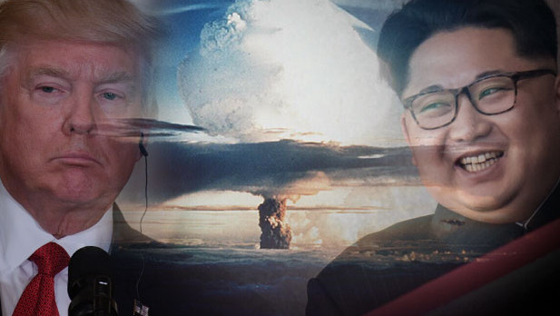
Lord, hear our prayers and deliver us from the forces of Satan threatening the Earth. Please keep us vigilant in prayer and fasting as we can fast. Amen.

Well, just a short note on fasting for all our Heartdwellers.

This is the longest period of fasting the Lord has ever asked of me. Carol, as well. I've been thinking, 'well, this fast is over now, after about three days or so' then I'd get another rhema: choose a fast. And I'd have to either switch what I was fasting on, or just take it as 'continue on this fast. Don't stop.'

I cannot do a total fast, but I can restrict the intake of pleasant foods and limit amounts. Do what you can, Heartdwellers. If you are pregnant or nursing—give up something that isn’t that great for the baby, like chocolate. If you need caffeine to function, because some people's systems have to be jump-started, then by all means, don’t cut that from your diet.

You can live for extended periods on a Daniel fast, or a somewhat vegetarian fast. Be sure you get a protein drink or what you need to function. Some vegetarians eat eggs, so that's a good source of protein.

I eat one meal a day, bread and almond butter for 3 snacks, fresh fruit and my protein drinks. This sustains me. Although I sure do get tired of bread and almond butter! But it sustains me, and I tried to do without the drinks but I got sick. So, please do not deprive your bodies 'till you collapse.

Also, don’t make it a point of pride that you fasted and others didn’t. That is truly obnoxious to the Lord and all of Heaven; better to do what you can in secret.

So, I am not really fasting but doing a partial fast.

On to the message. Ezekiel has had several warning dreams about war on our continent. They are getting closer together and more intense over the last two months, along with Rapture dreams and NWO detainment camps—which I've been having. And many, many Scripture readings and Rhemas pointing to war and the Rapture.

Last night, he dreamt that we had been nuked at a naval port in the Gulf coast (closest guess, it was in the U.S) and this area reminded him of where he grew up and that's the Gulf Coast. And there were Orientals in American army suits with American tanks and equipment firing on this naval base. Then a very large truck backed up to the entrance of a building where the skeleton crew was—mostly older clean-up crew people, etc. And pumped a liquid cement-like material into the building, immediately suffocating and encasing all the people inside. Very strange...

Ezekiel said a little dog was near some water and jumped into it, but squealed in pain and jumped out with his little legs burning. All the water in the area was about four feet high and radio-active or acidic from something. He climbed high up into a tree to avoid touching it.

Last year, I had a dream that North Koreans had done a Black Ops mission coming out of the Gulf of Mexico onto the beaches of Florida and taking over the peninsula.

More than a year ago, I had dreams about Texas being involved in an operation from Russia and somehow tied to the Koreans, who were snipers in the trees and forests moving north, in the east from Florida into the Arkansas/ Mississippi areas.

There are, we believe, plenty of N. Korean undercover cells in the U.S. that could be activated—this information is coming from a very credible source in the military. They would be familiar with the terrain, the layout, the habits of the people, and so on in the areas they lived in. Also they would be armed and ready to respond to orders.

I was somewhat confused by the American uniforms in his dream, because oriental people were wearing these uniforms—until I realized they could very well be working with Obama’s Deep State to destabilize the U.S., so he could see his dreams to destroy America take place another way. He and the Koreans working against their common enemy—the U.S.

If you go back in the messages, the Lord gave me a dream about Obama pretending to be an American, but really being a Muslim. And in cahoots with other Muslim nations to destroy the Mosque, to start a war and make way for the Jewish temple—which he, as antichrist and perhaps Mahdi, could take up residence and declare himself God.

Things are heating up and I’m not too sure how long we are going to have at this rate. All is dependent on our prayers. I know the Lord said he was going to deliver a blow to this nefarious government against the U.S., but it is difficult for me to piece together all this until He says something.

Lord, please will You straighten all this out for us?

Jesus began, "I am so glad you are asking. I have much to tell. As you see, more and more people are enduring hardships of all kinds and I am using this as a firewall against these plans coming to fruition.

"Still, it is a warning dream that there is still impending danger from outside sources. The Deep State government may receive blows, but certain other peoples are being called upon to join forces in overthrowing America.

"I cannot say at this time you have a full two years. I can say you may be nearing the end of the probation period. Two years is no time at all from now, and while we are holding the flood of evil back, it is still very strong and slowly gaining, using betrayal tactics to infiltrate and destroy.

"While President Putin may not join in on this, many in Russia still hold to the hardline doctrines and are not at all in agreement with him. His life has been spared many times by your prayers.

"I know, My love, you can only cover so much ground and that is why Ezekiel is getting these dreams and why you have had so many NWO nightmares. They are to warn you that these forces are moving ahead very slowly with their agendas.

"Yet, I promised you a setback and I am holding to that.

"This is why I have told you that N. Korea is not as dangerous as the underground, which will use any means to destroy this country—even arming and accessing N. Koreans to invade bases and destroy your defense systems.

"Pray more My People, more prayer, more prayer. Yes, this calls for more deliberate and focused prayer. Do not allow family situations or common, everyday things lull you into numbness and false sense of security. The threats are very real.”

I want to make a final point about this message. That was the end of the Lord's part. And that is, that the Lord sometimes gives us dreams that will be fulfilled many years down the line. I am not suggesting time frames, but He is STILL focusing me on music and getting proficient. That does not sound like the hammer is coming down within a year. If that were the case, I would think that He would say, 'Go ahead and work more with correspondence, one on one with people—which I would love to do.

And keep in mind that everything may be set to go on, and all of a sudden an act of God takes place and seriously delays the hostile movement. Remember, it is our prayers that are making the difference.

I confess that more immediate issues around me have been keeping me from seeing the bigger picture and that’s why Ezekiel is getting these dreams, to keep me balanced. We aren’t perfect… just believing in the Lord to make us perfect with His grace.

I love you, dear Heartdwellers. You all are my life in Christ and without such a sweet and wonderful family, I feel as though my life would have been in vain.

Let us keep brandishing the Sword of the Spirit and standing in the way of anti-Christ taking over.

